Assignment 2: Triangles and Z-buffering

CS 6366 Computer Graphic

Professor: Dr. Xiaohu Guo
Teaching Assistant: Ningna Wang

• This is an independent assignment. You must finish it on your own
• Please make sure submitting your assignment on eLearning before deadline

Overview
In the last assignment, we rendered a wireframe triangle on the screen, but it wasn’t very visually interesting. This time, we’ll take it a step further—drawing a solid triangle by rasterizing it.
Previously, after applying the viewport transformation, we called rasterize_wireframe(const Triangle& t). Now, you will implement the rasterization process yourself and call rasterize_triangle(const Triangle& t) to fill the triangle with color.
The workflow of the function is as follows:
1. Create a triangular 2D bounding box.
2. Iterate over all pixels within this bounding box (using their integer indices). Then, use the screen space coordinates of the pixel center to check whether the center point is inside the triangle.
3. If internal, compares the interpolated depth value at its location with the corresponding value in the depth buffer.
4. If the current point is closer to the camera, set the pixel color and update the depth buffer.

Two functions you need to modify are (in the rasterizer.cpp):
• rst::rasterizer::rasterize_triangle(): execute triangle rasterization algorithm
• static bool insideTriangle(): Tests whether the point is inside a triangle. You can modify the definition of this function, which means, you can update the return type or function parameters according to your own way.

Because we only know the depth values at the three vertices of the triangle, we need to use interpolation to obtain the depth values of the pixels inside the triangle. We've already taken care of this part for you, as it hasn't been covered in the course yet. The interpolated depth value is stored in the variable z_interpolated.

Please notice how we initialized the depth buffer and the sign of the z values. These two triangles have negative z values, which means that the smaller the value, the farther away from the viewpoint.

In this assignment, you don’t need to handle rotation transformations—simply return an identity matrix for the model transformation.
To test your implementation, we provide two hard-coded triangles. If your program is correct, the output image should match the example shown below:
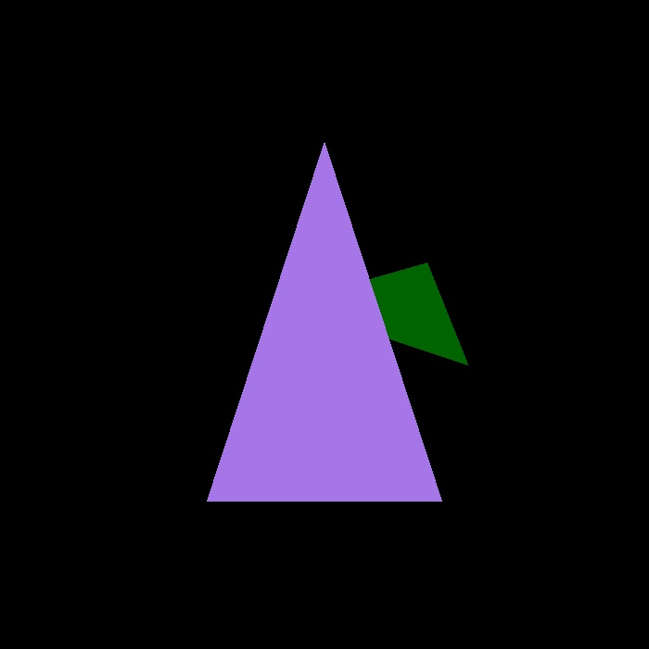

Coding

Notice that the get_projection_matrix() is empty, please copy and paste your implementation from Assignment1.

Grading and Submission

The grading criteria is as follow
- [1 point] All required files are submitted correctly. The code can be compiled and run correctly under set environment.
- [1 point] The perspective projection matrix is correctly constructed. (This will also be checked in Assignment 2, so please fix any errors if you are unable to do so in Assignment 1.)
- [3 points] Correctly implement the triangle rasterization algorithm.
- [2 points] Correctly test whether the point is inside the triangle.
- [3 points] Correctly implement the z-buffer algorithm to draw triangles sequentially on the screen.

Submission:
- Please compress all the following files into a single .zip archive named YOUR_NAME_Assignment2.zip.
  - CMakeLists.txt
  - All *.cpp files
  - All *.hpp/*.h files
  - An output image or screenshot of your result.

** Do NOT include your whole project in the submission. You will lose points for not deleting unnecessary files, like /.vs, /build, etc.
** all assignments must submit on eLearning on time. Submitting by email or other ways are NOT acceptable.

